1. Create HTML for web-page.jpg using bootstrap.

Bs11.html

<!doctype html>
<html lang="en">
<head>
<meta charset="UTF-8">
<meta name="viewport"
content="width=device-width, user-scalable=no, initial-scale=1.0, maximum-scale=1.0, minimum-scale=1.0">
<meta http-equiv="X-UA-Compatible" content="ie=edge">
<link rel="stylesheet" href="https://stackpath.bootstrapcdn.com/bootstrap/4.4.1/css/bootstrap.min.css" integrity="sha384-Vkoo8x4CGsO3+Hhxv8T/Q5PaXtkKtu6ug5TOeNV6gBiFeWPGFN9MuhOf23Q9Ifjh" crossorigin="anonymous">
<script src="https://code.jquery.com/jquery-3.4.1.slim.min.js" integrity="sha384-J6qa4849blE2+poT4WnyKhv5vZF5SrPo0iEjwBvKU7imGFAV0wwj1yYfoRSJoZ+n" crossorigin="anonymous"></script>
<script src="https://cdn.jsdelivr.net/npm/popper.js@1.16.0/dist/umd/popper.min.js" integrity="sha384-Q6E9RHvbIyZFJoft+2mJbHaEWldlvI9IOYy5n3zV9zzTtmI3UksdQRVvoxMfooAo" crossorigin="anonymous"></script>
<script src="https://stackpath.bootstrapcdn.com/bootstrap/4.4.1/js/bootstrap.min.js" integrity="sha384-wfSDF2E50Y2D1uUdj0O3uMBJnjuUD4Ih7YwaYd1iqfktj0Uod8GCExl3Og8ifwB6" crossorigin="anonymous"></script>
<link rel="stylesheet" href="bsstl11.css">
<title>web page using bootstrap</title>
</head>
<body>
<div class="container">
<header class="header1">
<h2 class="ttn">To The New</h2>
<div class="container-fluid">
<nav class="navbar navbar-expand-lg navbar-dark bg-dark">
<div class="collapse navbar-collapse">
<ul class="navbar-nav mr-auto">
<li class="nav-item active">
<a class="nav-link" href="#">HOME <span class="sr-only">(current)</span></a>
</li>
<li class="nav-item">
<a class="nav-link" href="#">ABOUT US</a>
</li>
<li class="nav-item">
<a class="nav-link" href="#">CAREER</a>
</li>
<li class="nav-item">
<a class="nav-link" href="#">CONTACT US</a>
</li>
</ul>
</div>
</nav>
</div>
</header>
<section class="sec1"><br>
<div class="sec2">
<h2 style="text-align: center; padding-top: 150px; color: white">960 x 360px</h2>
</div>
<div class="sec3">
<p>We are a digital technology company providing end-to-end product development services. We leverage the power of experience design, cutting-edge engineering, and cloud to build disruptive web and mobile apps enabling digital transformation for business.</p>
</div>
<br><br>
<div style="margin-left: 90px;">
LATEST FROM THE GALLERY
</div>
<hr>
<div class="row">
<div class="col-md-2 box" style="margin-left: 105px;">
<p>215 x 315 px</p>
<div class="row caption cap1">
<p>&nbsp;&nbsp;&nbsp;Image caption here </p>
</div>
</div>
<div class="col-md-2 box">
<p>215 x 315 px</p>
<div class="row caption cap1">
<p>&nbsp;&nbsp;&nbsp;Image caption here </p>
</div>
</div>
<div class="col-md-2 box">
<p>215 x 315 px</p>
<div class="row caption cap1">
<p>&nbsp;&nbsp;&nbsp;Image caption here </p>
</div>
</div>
<div class="col-md-2 box">
<p>215 x 315 px</p>
<div class="row caption cap1">
<p>&nbsp;&nbsp;&nbsp;Image caption here </p>
</div>
</div>
</div>
</section>
<footer class="row f1">
<div class="col-md-8"><p>Copyright @ 2009 - 2017 - All rights reserved - To The New</p></div>
<div class="col-md-4"><p>Web layout by To The New</p></div>
</footer>
</div>
</body>
</html>
bsstl11.css

body{
background-color: dimgrey;
}
.header1{
background-color: gray;
height: auto;
padding-bottom: 20px;
}
.ttn{
color: white;
font-weight: bold;
margin-left: 20px;
margin-top: 20px;
padding-top: 10px;
}
li>a{
font-weight: bold;
}
.sec1{
background-color: white;
height: 910px;
}
.sec2{
margin-left: 90px;
background-color: gray;
height: 400px;
padding-top: 30px;
margin-right: 87px;
}
.sec3{
margin-top: 20px;
width: 938px;
height: 50px;
background-color: lightgrey;
margin-left: 90px;
}
hr{
margin-left: 90px;
margin-right: 83px;
border-color: lightgrey;
border-width: 2px;
}
.box{
background-color: gray;
margin-left: 59px;
height: 250px;
text-align: center;
padding-top: 45px;
font-weight: bold;
padding-left: 46px;
padding-right: 46px;
}
.cap1{
background-color: lightgrey;
margin-top: 180px;
margin-left: -46px;
margin-right: -46px;
}
.f1{
background-color: #212529;
color: white;
font-weight: bold;
margin-left: 0px;
margin-right: 0px;
}
footer>div>p{
padding-left: 74px;
padding-top: 10px;
}

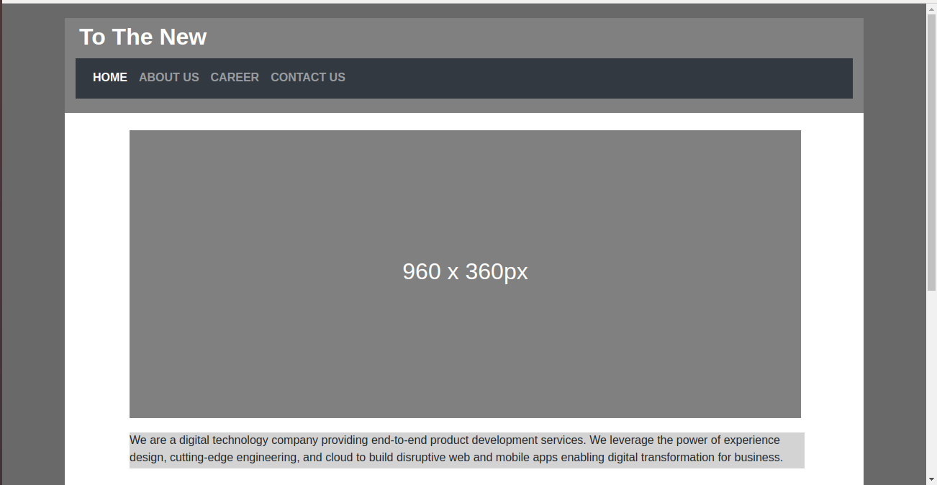

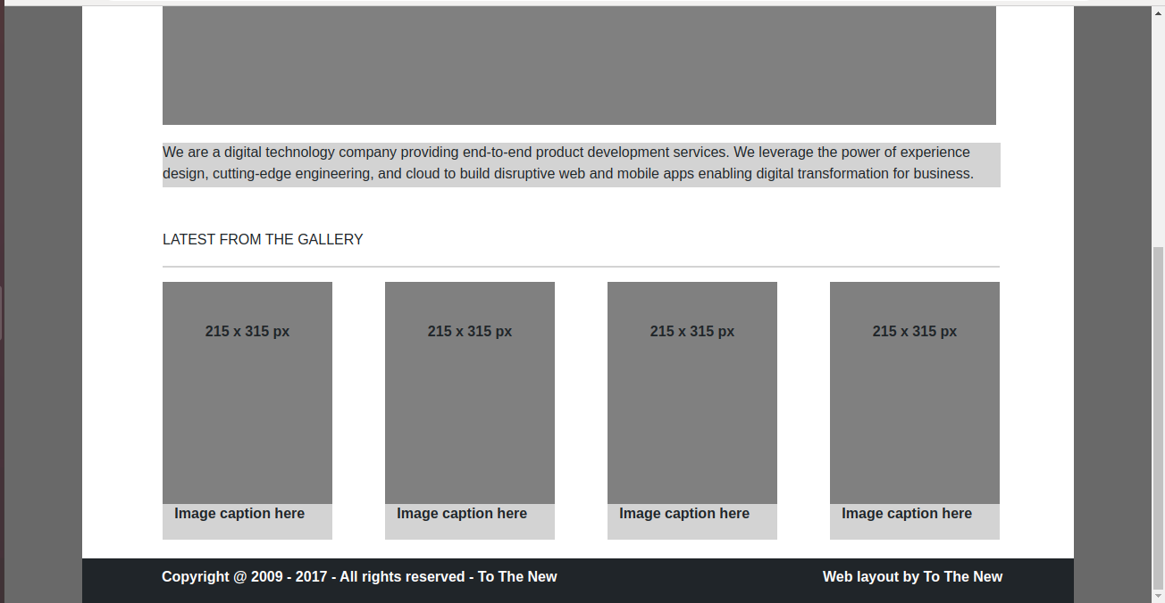

2. Create HTML for form.png using boostrap.

Form.html

<!DOCTYPE html>
<html lang="en">
<head>
<title>form using bootstrap</title>
<meta charset="utf-8">
<meta name="viewport" content="width=device-width, initial-scale=1">
<link rel="stylesheet" href="https://maxcdn.bootstrapcdn.com/bootstrap/3.4.1/css/bootstrap.min.css">
<script src="https://ajax.googleapis.com/ajax/libs/jquery/3.4.1/jquery.min.js"></script>
<script src="https://maxcdn.bootstrapcdn.com/bootstrap/3.4.1/js/bootstrap.min.js"></script>
<link href="formStyle.css" rel="stylesheet">
</head>
<body>
<header>
<nav class="navbar navbar-default">
<div class="container-fluid">
<div class="navbar-header">
<button type="button" class="navbar-toggle" data-toggle="collapse" data-target="#myNavbar">
<span class="icon-bar"></span>
<span class="icon-bar"></span>
<span class="icon-bar"></span>
</button>
<a class="navbar-brand " href="#">To The New</a>
</div>
<div class="collapse navbar-collapse" id="myNavbar">
<ul class="nav navbar-nav navbar-right">
<li><a href="#"> Home</a></li>
<li><a href="#"> Quick Help</a></li>
</ul>
</div>
</div>
</nav>
</header>
<div class="container">
<div class="row">
<div class="col-lg-3"></div>
<div class="col-lg-6 divCol6">
<div class="row report">
<h3>Bug Report</h3>
</div> <!---end of report row------>
<form>
<div class="forminput">
<div class="form-group">
<label for="title">Title:*</label>
<input type="title" class="form-control" id="title" name="title">
</div>
<div class="form-group">
<label for="desc">Description:*</label>
<textarea class="form-control" rows="5" id="desc"></textarea>
</div>
<div class="form-group">
<label for="os">Operating System:</label>
<select class="form-control" id="os">
<option>Windows XP</option>
<option>Linux</option>
<option>Mac</option>
</select>
</div>
<div class="form-group">
<label for="product">Product:</label>
<select class="form-control" id="product">
<option>Formoid</option>
<option>Formoid1</option>
<option>Formoid2</option>
</select>
</div>
<div class="form-group">
<label for="version">Version:*</label>
<input type="version" class="form-control verinput" id="version" name="version">
</div>
<div class="form-group">
<labbel for="radiobtn">License:</labbel><br>
<label class="radio-inline radiofirst">
<input type="radio" name="radiobtn">Free
</label>
<label class="radio-inline">
<input type="radio" name="radiobtn">Business
</label>
</div>
<div class="form-group">
<label for="severity">Severity:</label>
<select class="form-control" id="severity">
<option>Critical</option>
<option>Easy</option>
<option>Normal</option>
</select>
</div>
<div class="input-group">
<label for="attach">Attachment:</label>
<input type="text" class="form-control" placeholder="No File Selected" name="attach">
<div class="input-group-btn chbtndiv">
<button class="btn btn-default chfilebtn" type="submit">Choose File</button>
</div>
</div>
</div><!----end of inoutform div-------->
<div class="row rowbtn">
<div class=" pull-right">
<button type="submit" class="btn btn-lg btn-default subbtn">Send</button>
</div>
</div>
</form>
</div><!---end of col-llg-6------->
</div><!-----end of row----->
<br>
</div><!--------end of continare ----->
</body>
</html>

formstyle.css

*{
margin: 0;
padding: 0;
}
.navbar-default{
border: none;
box-shadow: 2px 5px 3px #ccc;

}
.navbar-default .navbar-brand{
color:rgb(93,188,210);
font-size: 28px;
}
.navbar-default .navbar-collapse .navbar-nav li a{
color: rgb(93,188,210);
font-size: 16px;
}
.divCol6{

border: 1px solid rgb(185,193,204);
border-radius: 5px
}
.report{
background-color: rgb(185,193,204);
color: white;
padding-left: 10px;
}
.forminput{
padding: 15px;
}
.verinput{
width: 30%;
}
.radiofirst{
margin-right: 150px;
}
.forminput select{
background-color: rgb(8,196,158);
color: white;
}
.chbtndiv{
padding-top: 25px;
}
.chfilebtn{
background-color: #ccc;
color: white;
}
.rowbtn{
background-color: rgb(185,193,204);
padding: 10px;
}
.subbtn{
background-color: rgb(8,196,158);
color: white;
border: none;;
}
@media only screen and (max-width: 600px) {
.verinput{
width: 100%;
}
.radiofirst{
margin-right: 0px;
}
}
